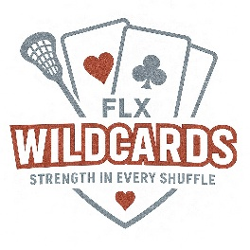
Photo Release Form

I hereby grant FLX Wildcards Girls Lacrosse Club (“the Club”), its coaches, volunteers, and representatives, the right and permission to: 1) take and use photographs and/or video recordings of me/my child during practices, games, tournaments, team events, or other activities related to the Club; and 2) use these photos/videos for promotional, educational, and informational purposes, including but not limited to social media, team communications, newsletters, flyers, fundraising materials, and local media coverage. I understand that: no compensation will be provided; images will not be sold to third parties; and consent may be revoked in writing at any time, but prior use remains valid.

Player Information:
Name:______________________________________________________DOB:___________________
Parent/Guardian Name: ______________________________________________________________

Please check one of the following:
___ I consent to use my child’s photo/video
___ I do NOT consent to use my child’s photo/video

Parent/Guardian Signature: ____________________________________________Date: _________

